|  |  |
| --- | --- |
| Use Case Name | Room Reservation |
| Domain | Travel |
| Complexity | Low |

Table of Contents

1. Business Objective 3

2. Functionality 3

3. Services for Customer 3

4. Scope and Limitations 3

5. Design Considerations / Assumptions 4

6. UI Screens / Pages 5

A. Welcome Page 6

B. User Login Page 7

C. Admin Login Page 8

D. Sign Up Page 9

E. Left Navigation / Menu Bar 11

F. Deluxe Non-AC Page (User Home Page) 12

G. Deluxe AC Page 14

H. Premier Suite Page 16

I. Admin - Booking details page (Admin Home Page) 18

J. Admin - Customer details page 21

7. APPLICATION FLOW 22

## Business Objective

The aim of this project is to create a Web application that allows users (Customers) to book hotel rooms and the hotel owner (admin) to view the customer’s information.

**Modules available to the users:**

* Sign Up
* Login
* Choose Room Type
  + - Book Rooms
* Logout

**Modules available to admin:**

* Login
* View Customer details
* Logout

## Functionality

* User can choose for the type of rooms and book the room accordingly.
* Admin can view the details of the customers and the rooms booked by them.

## Services for Customer

* Customers can choose and book rooms of their preference.

## Scope and Limitations

* Only registered users can book the rooms.
* User must be above 18 years of age and must provide a valid ID proof.
* No need to design payment page.
* Duration of stay should be at least one day.

## Design Considerations / Assumptions

* Use the in-memory database or cache to store the data. E.g.: H2/HSQL etc.,
* Do not use any file system to store the data
* **Admin Login Credentials**: admin@mymail.com/admin1234
* Assuming **only 3 different types of rooms** available and cost of one **extra bed** as Rs.**300**.
* Do not refer any third-party libraries (CSS/JS libraries) directly from internet in the code, instead download them and use as local reference.
* Variable **Identifier** of HTML should be id/name for input types, id for <div> and anchor text for <a> tags. It should be followed strictly.
* **Do not hard code port number and context root anywhere in the code**
* [http://host:port/contextroot/{path}](http://host:port/contextroot/%7bpath%7d)

In the above URL**,** *contextroot* isthe Context root of the application. You can use any value for **context root** in your local environment during development but **do not hardcode** it in the **application source code**, as the system will replace it with the dynamically generated name as context root and deploy in the application server to validate the functional test cases using selenium web driver API. In case if you are not using the context root (say for example, Dot Net Core and NodeJS applications may not really have the context root), it will be replaced with blank.

For example:

Java: <http://localhost:8080/contextroot/login>

Dot Net: <http://localhost:5001/login>

NodeJS: <http://localhost:3000/login>

(PORT number will be provided as an environment variable, use process.env.PORT)

* Use the below data for **Room tariff**.

**TABLE 1.1 ROOM TARIFF DATA:**

|  |  |  |  |  |
| --- | --- | --- | --- | --- |
| **Room Id** | **Room Type** | **Room Description** | **Ac / Non-AC** | **Cost per day** |
| 1 | Deluxe Non-AC | Accommodates 2 persons | Non-Ac | 700 |
| 2 | Deluxe AC | Accommodates 2 persons | AC | 1000 |
| 3 | Premier Suite | Accommodates 4 persons | AC | 3800 |

* **Extra bed** costs Rs.**300 per day**.

**Total Cost Calculation:**

Total Cost = No. of days * (cost per day+ (No. of extra beds *300))

E.g.

Book a **Deluxe Non-AC** room for **2 days** with **one extra bed**:

Total Cost = 2 * (700+ (1*300)) = 2000

For each booking, create a **booking id, which is unique,** starting from 1 and increment by 1. This generated booking id is unique and is visible for admin only, not for user, in booking details page.

## UI Screens / Pages

**Please read the below points carefully before you start the development of the use case.**

Each page should have the following:

* Title of the page
* All the input elements to capture the user input
* Buttons/Links for any actions like submit, cancel etc.,
* **All the HTML elements should have id or name attribute**
* **Element id or name should be unique and is case sensitive. If you use different names, the automated functional test cases will fail.**
* Success or Error message to be displayed should be wrapped in a <div> tag with the documented id/name. Please note the div id name is case sensitive.
* **Please use the success / error messages documented as is, otherwise the automated functional test cases will fail.**
* The colors that appear in the sample screen-shots of the views below are only indicative. You can choose to ignore using background colors for pages as it is **Optional** and in no way effects the functionality or evaluation of the application.

**Please use the** **design considerations / assumptions section** **to configure the master data without which the functional tests will fail.**

### Welcome Page

This page should display the buttons for signup, user login, admin login and Welcome text.

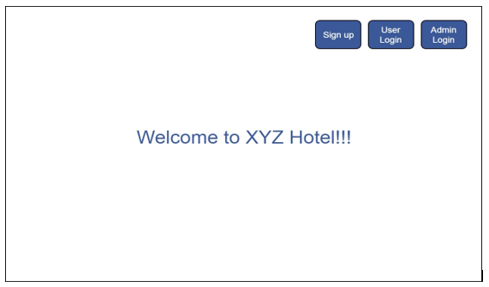

|  |  |  |  |  |
| --- | --- | --- | --- | --- |
| **Field / Page attribute** | **HTML Element Type** | **Required** | **Identifier** | **Validation** |
| URL | <http://localhost:port/contextroot/welcome> | | | |
| Title of the page | Title | Yes | Room Reservation - Welcome | |
| Sign up | Button | Yes | id=”signUp” | Should navigate to signup page on clicking. |
| User Login | Button | Yes | id=”userLogin” | Should navigate to user login page on clicking. |
| Admin Login | Button | Yes | Id=”adminLogin” | Should navigate to admin login page on clicking. |
| Description | Label |  |  | Welcome to XYZ Hotel!!! |

### B. User Login Page

This page allows the user to login into the application. Customer should be able to login into the application by providing all the data in mandatory fields. An error message should be displayed when the mandatory field is missing. On Successful login, user should navigate to user home page.

**Sample page looks like below:**

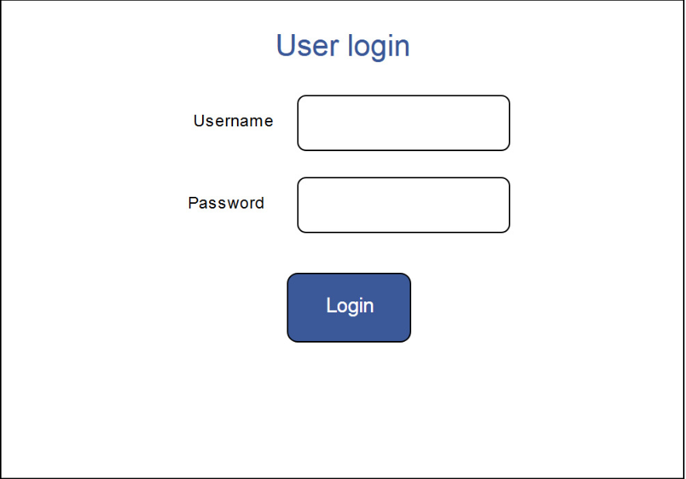

All text (user input) fields should not allow more than 40 characters by default unless it is explicitly mentioned at field level.

|  |  |  |  |  |
| --- | --- | --- | --- | --- |
| **Field / Page attribute** | **HTML Element Type** | **Required** | **Identifier** | **Validation** |
| URL | [*http://localhost:port/contextroot/*userlogin](http://localhost:8080/roomsreservation/userlogin) | | | |
| Title of the page | Title | Yes | Room Reservation - User Login | |
| User Name | Label |  |  |  |
| User Name | Text Box | Yes | id=”userName” | * Use registered email id to login. |
| Password | Label |  |  |  |
| Password | Password | Yes | Id=”password” | * Use password provided while registering |
| Login | Button |  | Id=”userLogin” | On successful login, navigate to user home page. Otherwise display the error message on top of the page. |
| Error Message | div |  | Id=”userError” | Div tag to display the error message:  “Invalid Credentials”. |

C. Admin Login Page

This page allows the admin to login into the application. Admin should be able to login into the application by providing all the data in mandatory fields. An error message should be displayed when the mandatory field is missing or invalid credentials. On Successful login, display admin home page.

**Sample page looks like below:**

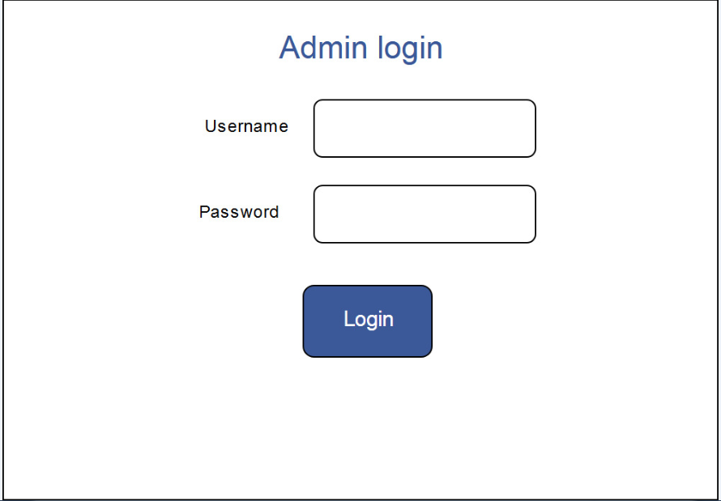

All text (user input) fields should not allow more than 40 characters by default unless it is explicitly mentioned at field level.

|  |  |  |  |  |
| --- | --- | --- | --- | --- |
| **Field / Page attribute** | **HTML Element Type** | **Required** | **Identifier** | **Validation** |
| URL | [*http://localhost:port/contextroot/*adminlogin](http://localhost:8080/roomsreservation/adminlogin) | | | |
| Title of the page | Title | Yes | Room Reservation - Admin Login | |
| User Name | Label |  |  |  |
| User Name | Text Box | Yes | id=”userName” | * Use details mentioned in assumptions section to login. |
| Password | Label |  |  |  |
| Password | Password | Yes | Id=”password” | * Use details mentioned in assumptions section to login. |
| Login | Button |  | Id=”adminLogin” | On successful login, display admin home page. Otherwise display the error message on top of the page. |
| Error Message | div |  | Id=”adminError” | Div tag to display the error message:  “Invalid Credentials”. |

1. Sign Up Page

Allows user to register himself before booking the room. Sign up page is only applicable for User, not for Admin.

**Sample page looks like below:**

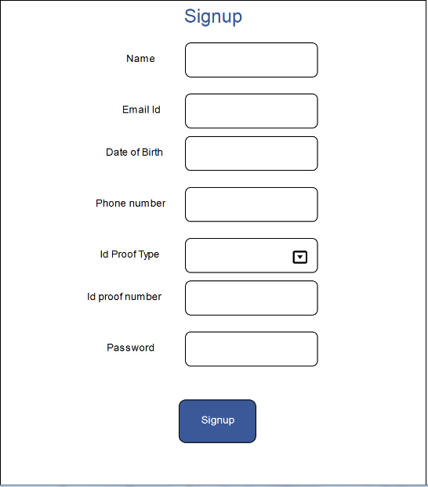

All text (user input) fields should not allow more than 40 characters by default unless it is explicitly mentioned at field level.

|  |  |  |  |  |
| --- | --- | --- | --- | --- |
| **Field / Page attribute** | **HTML Element Type** | **Required** | **Identifier** | **Validation** |
| URL | [*http://localhost:port/contextroot/*signup](http://localhost:port/roomsreservation/signup/) | | | |
| Title of the page | Title | Yes | Room Reservation - Sign Up | |
| Name | Label |  |  |  |
| Name | Text Box | Yes | id=”name” | Should allow only alphabets |
| Email Id | Label |  |  |  |
| Email Id | Text Box | Yes | id=”email” | Should be valid email id format |
| Date Of Birth | Label |  |  |  |
| Date Of Birth | Text Box | Yes | Id=”dob” | Date format should be “DD-MM-YYYY” |
| Phone Number | Label |  |  |  |
| Phone Number | Text Box | Yes | Id=”phNum” | Must be 10 digits and allow only numeric values |
| ID Proof Type | Label |  |  |  |
| ID Proof Type | Dropdown | Yes | Id=”proofType” | Dropdown Values:  PAN card  Voter Id  Passport  Driving License  Aadhar card |
| ID Proof Number | Label |  |  |  |
| ID Proof Number | Text Box | Yes | Id=”proofValue” | Should allow alphanumeric only. Min of 6 characters. |
| Password | Label |  |  |  |
| Password | Text Box | Yes | Id=”password” | Should be minimum of 8 characters. should allow only alphanumeric. |
| SignUp | Button |  | Id=”signUpButton” | On successful signup, display user home page, otherwise display the error message on top of the page in div tag with id = “signError” |
| Error Message | div |  | Id=”signError” | Invalid Data |

### E. Left Navigation / Menu Bar

You can create this as a left navigation on left side of the page as shown. This Left Navigation/Menu Bar should appear only for User login.

|  |  |  |  |
| --- | --- | --- | --- |
| **Field / Page attribute** | **HTML Element Type** | **Identifier** | **Remarks** |
| Deluxe Non-AC | Hyperlink / a href | Link Text = ”Deluxe Non-AC”  Ex: <a href=””>Deluxe Non-AC</a> |  |
| Deluxe AC | Hyperlink / a href | Link Text = ”Deluxe AC”  Ex: <a href=””>Deluxe AC</a> |  |
| Premier Suite | Hyperlink / a href | Link Text = ”Premier Suite”  Ex: <a href=””>Premier Suite</a> |  |

### F. Deluxe Non-AC Page (User Home Page)

Display the Deluxe Non-AC room booking page for the User. This page is applicable only for User, not for admin.

**Sample page looks like below:**

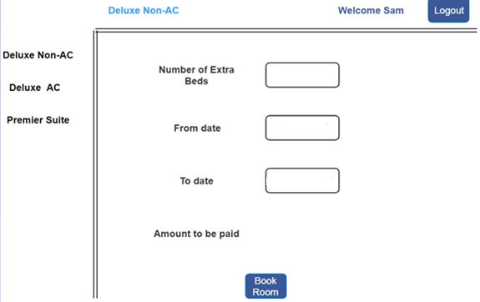

|  |  |  |  |  |
| --- | --- | --- | --- | --- |
| **Field / Page attribute** | **HTML Element Type** | **Required** | **Identifier** | **Validation** |
| URL | [*http://localhost:port/contextroot/*DeluxeNonAC](http://localhost:port/roomsreservation/DeluxeNonAC) | | | |
| Title of the page | Title | Yes | Room Reservation - Deluxe Non-AC | |
| Welcome User | Label |  | Id=”userWelcome” | Should display the welcome message as “Welcome Sam”.  Where “Sam” is the user name provided during registration. |
| Logout | Button | Yes | Id=”logout” | Terminate the user session and redirect to Welcome Page. |
| Number of extra beds | Label |  |  |  |
| Number of extra beds | Text Box | Yes | Id=”extraBeds” | Should allow only numbers.  Max 1 character  If no extra bed is needed, then need to mention as 0.  The allowed value: Any number between 0 and 9. |
| From Date | Label |  |  |  |
| From Date | Text Box | Yes | Id=”fromDate” | Date format should be “DD-MM-YYYY”  Max length: 10  Except format validation, **do not do** any other validation like today’s date etc. |
| To Date | Label |  |  |  |
| To Date | Text Box | Yes | Id=”toDate” | Should be greater than from date.  Date format should be “DD-MM-YYYY”  Max length: 10 |
| Amount to be paid | Label |  |  |  |
| Amount to be paid | Label | Yes | Id=”amount” | Amount should be calculated based on the tariff data given in design consideration section. **TABLE 1.1 ROOM TARIFF DATA** |
| Book Room | Button | Yes | Id=”bookRoom” | On successful booking, it should give success message, otherwise display the error message, on top of the page. |
| Success Message | div |  | Id=”bookSuccess” | Booking Successful |
| Error Message | div |  | Id=”bookError” | Invalid Data |

### G. Deluxe AC Page

Display the Deluxe AC room booking page for the User. This page is applicable only for User, not for admin.

**Sample page looks like below:**

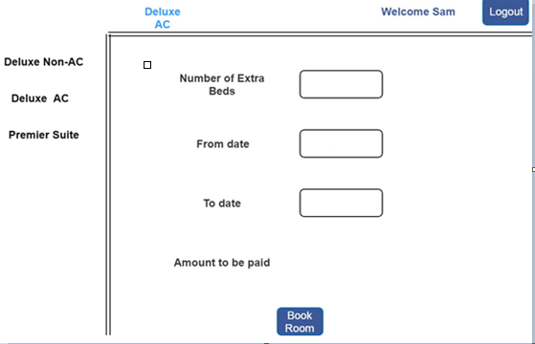

|  |  |  |  |  |
| --- | --- | --- | --- | --- |
| **Field / Page attribute** | **HTML Element Type** | **Required** | **Identifier** | **Validation** |
| URL | [*http://localhost:port/contextroot/*DeluxeAC](http://localhost:port/roomsreservation/DeluxeAC) | | | |
| Title of the page | Title | Yes | Room Reservation - Deluxe AC | |
| Welcome User | Label |  | Id=”userWelcome” | Should display the welcome message as “Welcome Sam”.  Where “Sam” is the user name provided during registration. |
| Logout | Button | Yes | Id=”logout” | Terminate the user session and display welcome page |
| Number of extra beds | Label |  |  |  |
| Number of extra beds | Text Box | Yes | Id=”extraBeds” | Should allow only numbers.  Max 1 character  If no extra bed is needed, then need to mention as 0.  The allowed value: Any number between 0 and 9. |
| From Date | Label |  |  |  |
| From Date | Text Box | Yes | Id=”fromDate” | Date format should be “DD-MM-YYYY”  Max length: 10  Except format validation, **do not do** any other validation like today’s date etc. |
| To Date | Label |  |  |  |
| To Date | Text Box | Yes | Id=”toDate” | Should be greater than from date.  Date format should be “DD-MM-YYYY”  Max length: 10 |
| Amount to be paid | Label |  |  |  |
| Amount to be paid | Label | Yes | Id=”amount” | Amount should be calculated based on the tariff data given in design consideration section. **TABLE 1.1 ROOM TARIFF DATA** |
| Book Room | Button | Yes | Id=”bookRoom” | On successful booking, display success message, otherwise display the error message, on top of the page. |
| Success Message | div |  | Id=”bookSuccess” | Booking Successful |
| Error Message | div |  | Id=”bookError” | Invalid Data |

### H. Premier Suite Page

Display the Premier Suite room booking page for the User. This page is applicable only for User, not for admin.

**Sample page looks like below:**

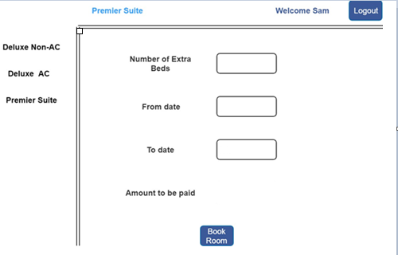

|  |  |  |  |  |
| --- | --- | --- | --- | --- |
| **Field / Page attribute** | **HTML Element Type** | **Required** | **Identifier** | **Validation** |
| URL | [*http://localhost:port/contextroot/*](http://localhost:port/roomsreservation/DeluxeAC)PremierSuite | | | |
| Title of the page | Title | Yes | Room Reservation - Premier Suite | |
| Welcome User | Label |  | Id=”userWelcome” | Should display the welcome message as “Welcome Sam”.  Where “Sam” is user name provided during registration. |
| Logout | Button | Yes | Id=”logout” | Terminate the user session and display welcome page |
| Number of extra beds | Label |  |  |  |
| Number of extra beds | Text Box | Yes | Id=”extraBeds” | Should allow only numbers.  Max 1 character  If no extra bed is needed, then need to mention as 0.  The allowed value: Any number between 0 and 9. |
| From Date | Label |  |  |  |
| From Date | Text Box | Yes | Id=”fromDate” | Date format should be “DD-MM-YYYY”  Max length: 10  Except format validation, **do not do** any other validation like today’s date etc. |
| To Date | Label |  |  |  |
| To Date | Text Box | Yes | Id=”toDate” | Should be greater than from date.  Date format should be “DD-MM-YYYY”  Max length: 10 |
| Amount to be paid | Label |  |  |  |
| Amount to be paid | Label | Yes | Id=”amount” | Amount should be calculated based on the tariff data given in design consideration section. **TABLE 1.1 ROOM TARIFF DATA** |
| Book Room | Button | Yes | Id=”bookRoom” | On successful booking, display success message, otherwise display the error message, on top of the page. |
| Success Message | div |  | Id=”bookSuccess” | Booking Successful |
| Error Message | div |  | Id=”bookError” | Invalid Data |

### 

### Premier Suite Page

### I. Admin - Booking details page (Admin Home Page)

Displays the booking details to the admin after login. It should display the data sorted by “Booking Id” in descending order (latest/recent bookings at the top and old bookings at the end). It should display “**No Records Found**” when there are no bookings to display.

**Sample page looks like below:**

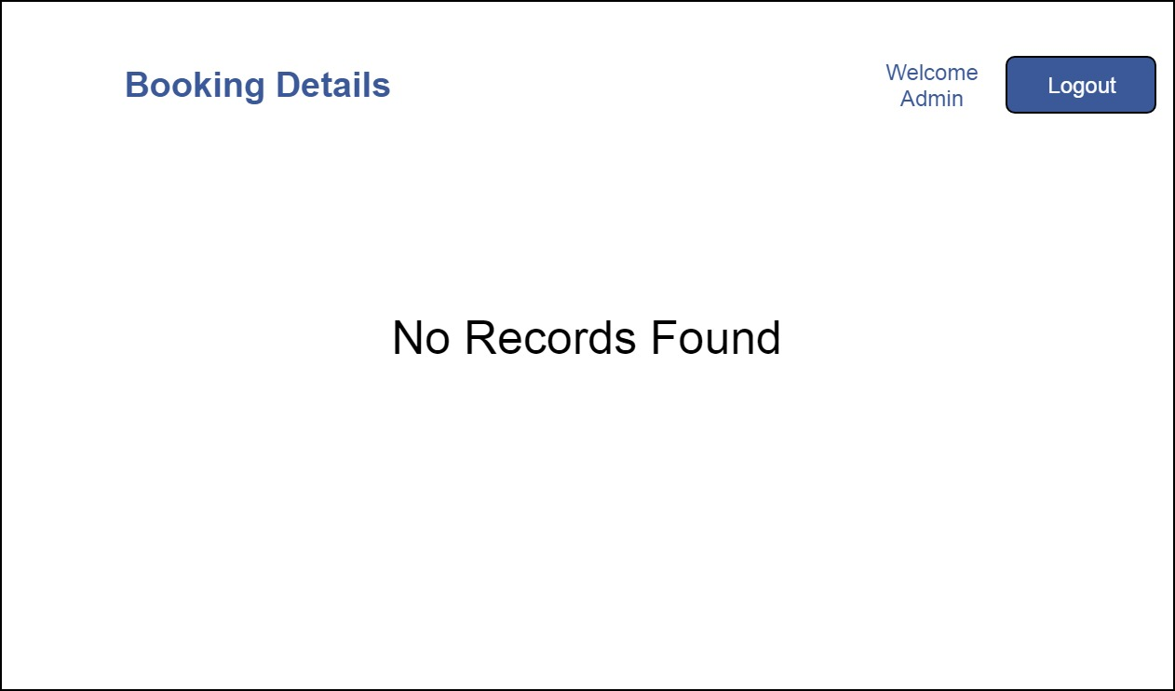

When there are no records to display:

|  |  |  |  |  |
| --- | --- | --- | --- | --- |
| **Field / Page attribute** | **HTML Element Type** | **Required** | **Identifier** | **Validation** |
| URL | [*http://localhost:port/contextroot/*bookingdetails](http://localhost:port/contextroot/bookingdetails) | | | |
| Title of the page | Title | Yes | Room Reservation - Booking Details | |
| Welcome admin | Label | Yes | Id=”welcomeMsg” | Should display the welcome message as “Welcome Admin” for admin user. |
| Logout | Button |  | Id=”logout” | Terminate the user session and display the welcome page. |
| No Records | Label | Yes | Id=”noRecordFound” | It should display “No Records Found” |

Once room is booked by the user, booking details page should have following details.

**Sample page looks like below:**

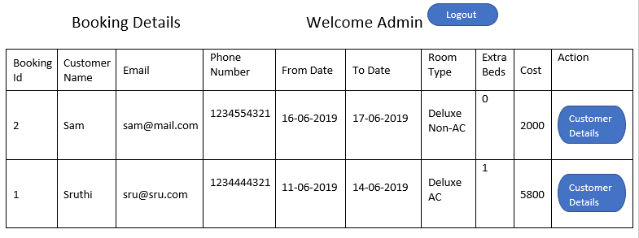

|  |  |  |  |  |
| --- | --- | --- | --- | --- |
| **Field / Page attribute** | **HTML Element Type** | **Required** | **Identifier** | **Validation** |
| URL | [*http://localhost:port/contextroot/*bookingdetails](http://localhost:port/contextroot/bookingdetails) | | | |
| Title of the page | Title | Yes | Room Reservation - Booking Details | |
| Welcome admin | Label | Yes | Id=”welcomeMsg” | Should display the welcome message as “Welcome Admin” for admin user. |
| Logout | Button |  | Id=”logout” | Terminate the user session and display the welcome page. |
| Booking Details | Label-Heading | | | Header of the table |
| Booking id | Column Header Text | | |  |
| Customer Name |  |
| Email |  |
| Phone Number |  |
| From Date |  |
| To Date |  |
| Room Type |  |
| Extra Beds |  |
| Cost |  |
| Action |  |
| Booking id | Label | Yes | Id=”bookingId1” for row 1  Id=”bookingId2” for row 2 etc., | Label with id to display the Customer id. <label id=”bookingId1”>xxx</label> |
| Customer Name | Label | Yes | Id=”customerName1” for row 1  Id=”customerName2” for row 2 etc., | Ex:  <label id=”customerName1”>xxx</label> |
| Email | Label | Yes | Id=”email1” for row 1  Id=”email2” for row 2 etc., | Ex:  <label id=”email1”>xxx</label> |
| Phone Number | Label | Yes | Id=”phoneNumber1” for row 1  Id=”phoneNumber2” for row 2 etc., | Ex:  <label id=”phoneNumber1”>xxx</label> |
| From Date | Label | Yes | Id=”fromDate1” for row 1  Id=”fromDate2” for row 2 etc., | Ex:  <label id=”fromDate1”>xxx</label> |
| To Date | Label | Yes | Id=”toDate1” for row 1  Id=”toDate2” for row 2 etc., | Ex:  <label id=”toDate1”>xxx</label> |
| Room Type | Label | Yes | Id=”roomType1” for row 1  Id=”roomType2” for row 2 etc., | Ex:  <label id=”roomType1”>xxx</label> |
| Extra beds | Label | Yes | Id=”extraBeds1” for row 1  Id=”extraBeds2” for row 2 etc., | Ex:  <label id=”extraBeds1”>xxx</label> |
| Cost | Label | Yes | Id=”cost1” for row 1  Id=”cost2” for row 2 etc., | Ex:  <label id=”cost1”>xxx</label> |
| Customer Details | Button | Yes | Id=”custDetails1” for row 1  Id=”custDetails1” for row 2 etc., | Take user to customer details page |
| Logout | Button |  | Id=”logout” | Terminate the session and display the welcome page |

### J. Admin - Customer details page

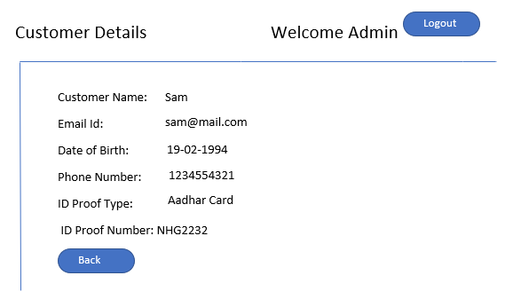

|  |  |  |  |  |
| --- | --- | --- | --- | --- |
| **Field / Page attribute** | **HTML Element Type** | **Required** | **Identifier** | **Validation** |
| URL | [*http://localhost:port/contextroot/*customerdetails](http://localhost:port/contextroot/customerdetails) | | | |
| Title of the page | Title | Yes | Room Reservation - Customer Details | |
| Welcome admin | Label | Yes | Id=”welcomeMsg” | Should display the welcome message as “Welcome Admin” for admin user. |
| Logout | Button |  | Id=”logout” | Should allow the user to logout from the session |
| Customer Details | Label-Heading | | | Header of the table |
| Customer Name | label |  |  |  |
| Customer Name | Label | Yes | Id=”custName” | Ex:  <label id=”custName”>xxx</label> |
| Email Id | Label |  |  |  |
| Email Id | Label | Yes | Id=”custEmail” | Ex:  <label id=”custEmail”>xxx</label> |
| Date of Birth | Label |  |  |  |
| Date of Birth | Label | Yes | Id=”custDob” | Ex:  <label id=”custDob”>xxx</label> |
| Phone Number | Label |  |  |  |
| Phone Number | Label | Yes | Id=”custPhone” | Ex:  <label id=”custPhone”>xxx</label> |
| ID Proof Type | Label |  |  |  |
| ID Proof Type | Label | Yes | Id=”custIdType” | Ex:  <label id=”custIdType”>xxx</label> |
| ID Proof Number | Label |  |  |  |
| ID Proof Number | Label | Yes | Id=”custIdValue” | Ex:  <label id=”custIdValue”>xxx</label> |
| Back | Button | Yes | Id=”custBack” | Display booking details page. |

# 7. APPLICATION FLOW

|  |  |  |
| --- | --- | --- |
| **Current Page** | **Action** | **Next / Landing Page** |
| Welcome |  | Sign Up, User Login and Admin Login buttons will be available to go to the next page |
| SignUp | Submit=Success | User Home Page |
| SignUp | Submit=Failure | Display Sign Up page with error message |
| User Login | Submit=Success | User Home Page |
| User Login | Submit=Failure | Display User Login page with error message |
| Any Page / Left Navigation | Click on “Deluxe Non-AC” Link | Deluxe Non-AC Page |
| Any Page / Left Navigation | Click on “Deluxe AC” Link | Deluxe AC Page |
| Any Page / Left Navigation | Click on “Premier Suite” Link | Premier Suite Page |
| Deluxe Non-AC Page / Deluxe AC Page / Premier Suite Page | Click on "Book Room" button | Display the success message if the room is booked, otherwise display the error message on top of the same page. |
| Logout | Click on “Logout” button | Logout the user and redirect to welcome Page. |
| Admin Login | Submit=Success | Booking details Page |
| Admin Login | Submit=Failure | Display Admin Login page with error message |
| Booking details Page | Click on “Customer Details” button | Customer details page |
| Customer details page | Click on “Back” button | Booking details page |